**KARMELLA S. ROSILLAS**

018 Sucol, Calumpit, Bulacan

Contact No: 0916 866 1908

Email: [cba2019.karmella@gmail.com](mailto:cba2019.karmella@gmail.com)

**OBJECTIVE:**

To work in a company where I could find career growth and fully apply my skills and knowledge.

**PERSONAL INFORMATION:**

Date of Birth: January 21, 1991

Place of Birth: Laguna

Age: 34 Years old

Sex: Female

Civil Status: Single

**WORK EXPERIENCE:**

**» ClearDesk**

9255 Towne Center Drive, Suite 330, San Diego, CA 92121

Real Estate Social Media Manager

October 2023 – September 2024

**» Morgan Fidelity Associates**

2200 W Commercial Blvd Ste 306 Ft. Lauderdale, FL 33309

Appointment Setter / Sales Associate

July 2020 – September 2023

**» Cynet Virtual Advantage**

E & A Building, Gonzales Avenue, San Vicente, Pampanga Appointment Setter

October 2019 – June 2020

**» BPO Calling Real Estate Agent**

Cabana N4 4th Floor, Brgy. Longos, City of Malolos, Bulacan Telemarketer

E & A Building, Gonzales Avenue, San Vicente, Pampanga Appointment Setter

September 2016 - July 2019

**» Call 2 Connect Solutions Inc.**

22/F Trafalgar Plaza, 105 H.V. Dela Costa St., Salcedo Village, Makati Call Center Associate June

2014 - August 2016

**EDUCATIONAL ATTAINMENT:**

» University of Perpetual Help System ( Jonelta ) BS Nursing

National Hi-way, Sto. Niño, Biñan, Laguna 2007 - 2011

» San Lorenzo School

08 Mayumi St., United San Pedro Subdivision San Pedro, Laguna

2003 - 2007

» San Lorenzo School

08 Mayumi St., United San Pedro Subdivision San Pedro, Laguna

1997 – 2003

# HONORS & AWARDS:

» Buyer Appointment Setter of the Year (Morgan Fidelity Associates)

» Top Agent of the Month for 31 Months (BPO Calling Real Estate Agent)

» Top Agent of the Year for 2 Years (BPO Calling Real Estate Agent)

» Reliability Award for 30 Months

(No Late/s, No Absences)

(BPO Calling Real Estate Agent)

» Outstanding Performance as a Call Center Associate (Call 2 Connect Solutions Inc.)

# CHARACTER REFERENCE:

» Hazel De Jesus

Virtual Assistant

09428250588

» Joshua Nieto

Customer Success Manager

09262648501

I hereby certify that the above information is true and correct to the best of my knowledge and belief.

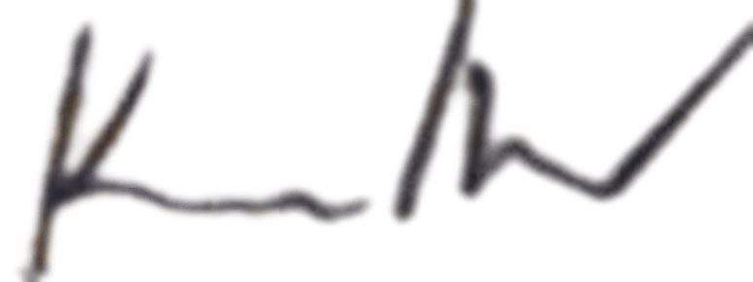

Karmella S. Rosillas Applicant