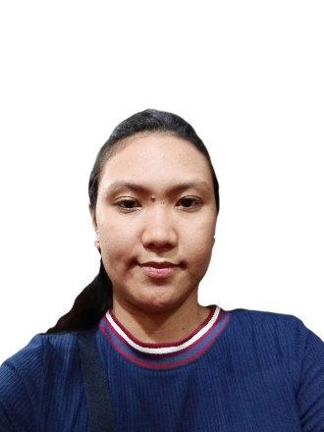

**Bandianon, Jershey Coleen**

**Address: Blk 8 Lt 25 South Pedracio St. Barangay Dalig, Antipolo City**

***Email Address:* Jersheybandianon@gmail.com**

***Cellular No.:* 09617586337 / 09625584080**

**OBJECTIVE**

To use my ability to work. I am motivated and able to work independently as well as a collaborative

member of a group. I believe that my fast-learning, strong communication will let me work under

your organization.

**PERSONAL INFORMATION**

Age : 26 years old

Birthdate : July 18, 1998

Birth Place : Quezon City

**EDUCATION**

**Secondary**

San Mateo National High School

2010-2014

**Primary**

Guitnangbayan Elementary School

2004-2010

**SKILLS, KNOWLEDGE AND ATTITUDE**

* Good Communication Skills
* Hardworking
* Good Time Management
* Goal Oriented
* Flexible
* Team Player

**WORK EXPERIENCE**

**Quality Cold Callers**

**Real Estate Cold Caller**

**(CURRENT)**

* Started working part-time for 7 months and have now transitioned to focusing on full-time cold calling for the past 3 months.
* Conducted outbound cold calls to prospective leads to generate interest in buying, selling, or renting properties.
* Utilized effective communication and persuasion techniques to engage leads and qualify them as potential clients.
* Presented property listings, features, and benefits to prospects to drive interest and schedule appointments.
* Followed-up on leads generated through marketing campaigns, referrals, and networking events.
* Built and maintained a pipeline of potential clients by nurturing relationships and providing ongoing communication.
* Documented lead interactions and updated lead information in the CRM system accurately.
* Participated in ongoing training and development programs to enhance sales skills and real estate knowledge.
* Adhered to compliance and regulatory guidelines while ensuring ethical sales practices.

**Optum Global Solution, Inc**

**United Healthcare Group Account Customer Representative**

**(July 1, 2022 – January 15, 2024)**

* Managed customer inquiries, complaints, billing questions, and requests for payment extensions or services. Skillfully de-escalated situations with angry callers, rebuilt trust, and identified resources for effective problem resolution, offering optimal solutions.
* Established as the go-to mentor for new representatives and handled particularly challenging calls, serving as a primary mentor for both new and seasoned employees.
* Played a pivotal role in achieving the highest customer service ratings, recognized by external auditors. Received numerous certificates from the company and received formal compliments from satisfied customers.
* Voluntarily completed customer service training to enhance skills, focusing on ways to improve customer satisfaction and boost productivity.
* Proficient in Level 3 Party Skills, handling inbound and outbound calls, providing web technical support, analyzing fraud cases, and engaging in sales activities for insurance subscriptions.

**Alorica Teleservices, Inc.**

**Credit One & US Bank Account**

**(June 10, 2021 – June 22, 2022 )**

* Highly experienced and reliable Customer Service representative with remarkable experience in the financial services industry
* Managed a high volume of incoming calls from credit card customers regarding inquiries, account management, and dispute resolution.
* Conducted outbound calls to existing and prospective customers to promote US Bank products and services.
* Educated customers on credit card features, benefits, and rewards programs to maximize card usage and customer retention.
* Collect customer information and input data into the system, ensuring confidentiality at all times
* Processed credit card applications, reviewed creditworthiness, and assisted customers with the application process.
* Collaborated with other departments such as fraud prevention, collections, and account services to resolve complex customer issues.
* Built and maintained relationships with customers to foster loyalty and repeat business.
* Provided accurate and detailed information about US Bank products, including checking accounts, savings accounts, loans, and credit cards.

**Inspiro Philippines**

**Seasonal Account (1800Flowers.com)**

**(August 14, 2019 – February 20, 2020)**

* Assisting customers and manage products they purchaces with passion and creativity into each gift.
* Consistently achieved monthly upselling targets by providing exceptional customer service

**CONTACT REFERENCE**

* Maria Theresa Causin Bandianon

Freelance/Virtual Assistant

09952995895

* Michelle Ann Causin Bandianon

Freelance Real Estate Cold caller

09326389016

* Hazel Jules Honeylet Bandianon

Senior Operations Manager

09171171572

*I hereby certify that all the information I have given is factual to the best of my knowledge.*



__________________

Applicant’s Signature