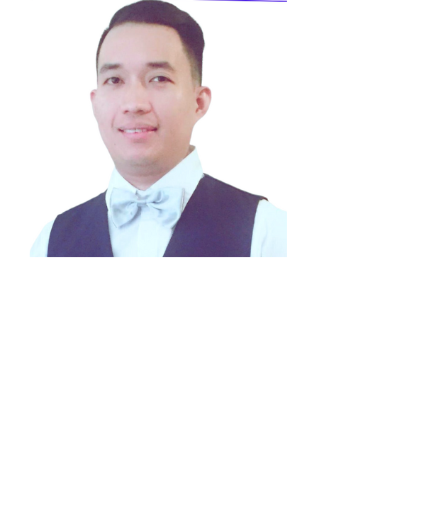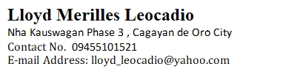



**OBJECTIVE**

I am capable of working in the level of my ability and willing to learn with challenges in the working field. I am versatile, flexible and confident when it comes to work.



**NOWCOM Global services -** [Address](https://www.google.com/search?sca_esv=7ff11094db11a47b&biw=1920&bih=919&q=nowcom+address&ludocid=14224302955751950638&sa=X&ved=2ahUKEwiStuvtrsGLAxUam68BHTHnIzYQ6BN6BAgfEAI): 30th & 33rd Floors, Raffles Corporate Center, F. Ortigas Jr. Road, Pasig City, 1605 Metro Manila

**July 15, 2024 – February 14, 2025**

**Customer Service Representative**

**WFM -** Financial Account

- Inbound calls present valuable opportunities for customers to explore their car loan options and potential extensions. Address billing inquiries promptly and facilitate seamless loan payment processing to enhance customer satisfaction and build trust.

**Support Zebra**  **– CDO, PH**

**November 27, 2023 – June 05, 2024**

**Customer Service Representative**

• When customers called in to place orders, I offered promotions to encourage them to take advantage of our company branding and excellent service.

• To help customers find the perfect solution and get the most out of what's available, go the extra mile by putting in more effort than required in each situation. Consider the readers and their needs and make the most important information clear by mentioning it first and keeping sentences short. Use simple language and active voice to increase clarity and conciseness.

**Teleperformance Philippines – CDO, PH**

**March 20, 2018 – November 05, 2023**

**Customer Service Representative /Mentor / Supervisor**

• Started as Customer Service Representative, then got promoted as Mentor/SME

• I supported new employees during production nesting by sharing product information and customer service strategies.

• Schedule a coaching session with the team to monitor their KPIs and provide expert resolutions. This will help us achieve our goals more efficiently and effectively

• When customers called in to place orders, I offered promotions to encourage them to take advantage of our company branding and excellent service.

• To help customers find the perfect solution and get the most out of what's available, go the extra mile by putting in more effort than required in each situation. Consider the readers and their needs and make the most important information clear by mentioning it first and keeping sentences short. Use simple language and active voice to increase clarity and conciseness.

• We listen to calls to assess quality and evaluate representative performance.

**Palazzo Versace Hotel**

Dubai,

United Arab Emirates

**April 1, 2017 - August 30, 2017**

**Commis 3**

* perform all the tasks in the kitchen other than cooking and serving
* responsible for the hygiene of the kitchen and they have to clean so the kitchen remains clean before the surprise inspections
* fill up the positions of the absent staff and complete their duties
* train any new members of the kitchen staff

**Papa John’s Pizza**

Dubai,

United Arab Emirates5

**January 19,2016- March 1, 2017**

**Kitchen Crew**

* perform all the tasks in the kitchen other than cooking and serving
* responsible for the hygiene of the kitchen and they have to clean so the kitchen remains clean before the surprise inspections
* fill up the positions of the absent staff and complete their duties
* train any new members of the kitchen staff regarding the work culture of the kitchen

**Naif Chicken Restaurant**

Abu Halifa, Kuwait

**March 1, 2012- Up to October 10, 2015**

**Function: Accounting Clerk**

**Job description:**

**-**Receive payment by cash, check, credit cards, vouchers, or automatic debits.

-Issue receipts, refunds, credits, or change due to customers.

-Count money in cash drawers at the beginning of shifts to ensure that amounts are correct and that there is adequate change.

-Establish or identify prices of goods, services or admission, and tabulate bills using calculators, cash registers, or optical price scanners.

-Perform filing and general administrative tasks.

-Maintain clean and orderly checkout areas

-Issue trading stamps, and redeem food stamps and coupons

-Compute and record totals of transactions

-Greet customers entering establishments.

-Offer customers carry-out service at the completion of transactions.

**DPWH ( Department of Public Works and Highways )**

Region X, Cagayan de Oro City, Misamis Oriental, Philippines

August 12, 2009 - June 30, 2011

**Function: Computer Operator**

**Job description:**

**-**Enter commands, using computer terminal, and activate controls on computer and peripheral equipment to integrate and operate equipment.

**-**Monitor the system for equipment failure or errors in performance.

**-**Answer telephone calls to assist computer users encountering problems.

**-**Read job set-up instructions to determine equipment to be used, order of use, material such as disks and paper to be loaded, and control settings.

**SCF General Manpower Services**

Region X, Cagayan de Oro City, Misamis Oriental, Philippines

May 2, 2008- October 16, 2008

**Function: Nestle Factory Worker**

**Job description:**

**-**Observe machine operations to ensure quality and conformity of filled or packaged products to standards.

**-**Tend or operate machine that packages product.

**-**Remove finished packaged items from machine and separate rejected items.

**-**Stock and sort product for packaging or filling machine operation, and replenish packaging supplies, such as wrapping paper, plastic sheet, boxes, cartons, glue, ink, or labels.

**-** Inspect and remove defective products and packaging material.

**-**Clean, oil, and make minor adjustments or repairs to machinery and equipment, such as opening valves or setting guides.

**-**Start machine by engaging controls.

**-**Clean packaging containers, line and pad crates, and/or assemble cartons to prepare for product packing.

**D1st Pawnshop INC.**

Region X, Cagayan de Oro City, Misamis Oriental, Philippines

July 5, 2007 – January 15, 2008

**Function: Salesman / Cashier**

**Job description:**

**-**Greet customers and ascertain what each customer wants or needs.

-Open and close cash registers, performing tasks such as counting money, separating charge slips, coupons, and vouchers, balancing cash drawers, and making deposits.

-Compute sales prices, total purchases and receive and process cash or credit payment.

-Maintain records related to sales

-Recommend, select, and help locate or obtain merchandise based on customer needs and desires.

-Prepare sales slips or sales contracts.

-Inventory stock and requisition new stock.

**On Job Training**

**Publishing Center, Liceo de Cagayan University**

Region X, Cagayan de Oro City, Misamis Oriental, Philippines

April 1 – 2006 – May 28, 2006

**Function: Computer Operator**

**SEMINARS ATTENDED**

* **4th Cagayan de Oro City – Wide Information Technology Convention**

Lauremar Beach Resort , Opol Misamis Oriental, Philippines

December 9 – 10, 2006

* **Linux Network Operating System Administration**

Dynasty Court Hotel, Cagayan de Oro City, Philippines

February 3, 2007

* **Wide Area Networking Router Configuration**

Philtown Hotel, Cagayan de Oro City, Philippines



**PERSONAL**

**Age:**  38 years old

**Gender:** Male

**Date of Birth:** November 19, 1985

**Place of Birth:** Cagayan de Oro City, Philippines

**Civil Status:** Single

**Height:** 5’6”

**Weight:** 70 kilograms

**Religion:** Born-Again Christian

**Citizenship:** Filipino

**Language Spoken:** English, Filipino, Cebuano, Basic Arabic

**Skills:** **Computer Literate ( Microsoft Word, Microsoft Excel Networking, AutoCAD 3D, Adobe Flash, C+, Java)**

**EDUCATIONAL BACKGROUND**

**Bachelor of Science in Information Technolog** 2003 - 2007

Liceo de Cagayan University

Cagayan de Oro City, Philippines

**Corpus Christi High School** 1999 - 2003

Macasandig, Cagayan de Oro City

Cagayan de Oro City, Philippines

**Cagayan de Oro Christian School** 1993-1999

F. Abellanosa St. Cagayan de Oro City

Cagayan De Oro City, Philippines